Software Requirements Specification

for

Sports Complex Management System

Version 1.0 approved

Prepared by:

Hamna Naveed 346470

Hamna Rauf 349069

Syeda Sana Zehra Zaidi 339278

Sports Complex

5th November 2021

Table of Contents

Table of Contents ii

Revision History ii

1. Introduction 1

1.1 Purpose 1

1.2 Document Conventions 1

1.3 Intended Audience and Reading Suggestions 1

1.4 Product Scope 1

2. Overall Description 2

2.1 Product Perspective 2

2.2 Product Functions 2

2.3 User Classes and Characteristics 3

2.4 Operating Environment 4

2.5 Design and Implementation Constraints 4

2.6 Assumptions and Dependencies 5

3. External Interface Requirements 6

3.1 User Interfaces 6

3.2 Hardware Interfaces 31

3.3 Software Interfaces 31

4. System Features 31

4.1 Login/logout 31

4.2 Register User 31

4.3 Delete User 34

4.4 Edit Details 34

4.5 Edit Working Hours 35

4.6 Complaint and Suggestions 35

4.7 Generate payroll 35

4.8 Bill Payment 36

4.9 Credit Membership 36

4.10 Allocate Funds 37

4.11 View Transactions 37

4.12 Print Transactions 37

4.13 Issue Notice 38

4.14 View Notice 38

4.15 View Supervisor Attendance 38

4.16 View Complaints and Suggestions 38

4.17 View Repairs 39

4.18 View Emergency 39

4.19 Change Password 40

4.20 Maintenance Checkup 40

4.21 Edit Repair 41

4.22 View Trainee 41

4.23 View Schedule 41

4.24 Mark Attendance 41

4.25 View Medical Details 42

4.26 View Inventory 42

5. Other Nonfunctional Requirements 43

5.1 Performance Requirements 43

5.2 Safety Requirements 43

5.3 Security Requirements 43

5.4 Software Quality Attributes 43

5.5 Business Rules 44

6. Other Requirements 44

Appendix A: Glossary 44

Revision History

|  |  |  |  |
| --- | --- | --- | --- |
| **Name** | **Date** | **Reason For Changes** | **Version** |
|  |  |  |  |
|  |  |  |  |

# Introduction

## Purpose

This Software Requirement Specification (SRS) provides an exhaustive depiction of the requirements for the “SPORTS COMPLEX MANAGEMENT SYSTEM”. It elucidates the design, plan and complete implementation of the system. It clarifies system and organizational constraints, interfaces and interaction between interfaces and with other external applications. This document will facilitate the developers gaining insight on what the customer requires and in what priority order.

## Document Conventions

This SRS follows the following convention:

Font: Times, Size: 18 -> Main Headings

Font: Times, Size: 14 -> Sub Headings

Font: Arial, Size: 11 -> Paragraphs

All levels of headings are kept in bold

## Intended Audience and Reading Suggestions

This document is aimed for the developers or software engineering students who will implement an efficient system fulfilling all the customer requirements. It is recommended for every user to refer to the table of contents prior to starting to get them familiarized with their relevant area.

## Product Scope

This project aims to shift the management of Sports Complex from paper-based to software-based implementation. This will help to optimize the tedious and cumbersome file work with the help of a user-friendly interface. Every user in every department in the Sport Complex will have their own terminal with system security checks and constraints ensured. This project will be a two-tier implementation and will not require internet connection for its operation.

# Overall Description

## Product Perspective

This project is a new self-contained product offering following:

**Registration**:

The registration department has the access to register and remove employees, members, teams, trainees, participants of the tournaments, and guests.

**Finance**:

Finance department is responsible for all kind of transactions. It can generate payrolls, credit memberships, allocate funds for the extras and tournaments, and pay monthly bills of the Sports Complex.

**Maintenance and Repairs**:

They ensure regular maintenance check-ups and can request for repair funds.

**Inventory**:

The inventory department maintains the records of items associated with the Complex. This includes the regular borrow and return of objects and request of funds for the new items when required.

**Emergency**:

This department maintains records of all the emergencies occurring in the Complex.

**Manager**:

Manager will have access to complaints and suggestions, repairs, emergencies, and attendance of the supervisors. Manager can further issue notices that will be accessible to all users.

## Product Functions

The major functions the product must perform or must let the user perform are:

|  |  |
| --- | --- |
| **Product Functions** | **Accessible To** |
| Login / Logout | All Users |
| Report Complaints & Suggestions |
| Edit Profile |
| Change Password |
| Register Users and Memberships | Registration Department |
| Delete Users |
| Edit Working Hours for Coaches |
| View Trainees |
| View Tournament Details |
| Generate Payrolls | Finance Department |
| Bill Payment |
| View All Transactions |
| Credit Memberships |
| Allocate Funds | Supervisor of Finance Department |
| Issue Notices | Manager |
| View Supervisor Attendance |
| View Complaints & Suggestions |
| View Emergencies |
| View Repairs |
| Maintenance Track | Maintenance and Repair Department |
| Repair Details |
| Issue From Inventory | Inventory |
| Add To Inventory |
| Remove From Inventory |
| Mark Attendance | Attendant of Registration Dept |
| Emergency Details | Emergency |

## User Classes and Characteristics

Each department of the Sport Complex embodies several employees having various roles:

**Registration**:

All kind of registrations in the Sports Complex are handled by the members of Registration Department. They are responsible for adding and deleting employees from the database, linking trainees to the coaches keeping in view the domain of both and working hours of the coach. Membership cards for the individuals and teams are issued by the same. Further, tournament registrations are also dealt with.

**Finance**:

Finance department is responsible for all kind of transactions. Salary record of all the employees is maintained and monthly payrolls are generated. The fee of every member based on the facilities availed is calculated, collected and maintained. The electricity, gas and WIFI bills, insurance and tax are paid by the finance department and their records are maintained.

**Supervisor of Finance Department**

Funds for the repairs, tournaments and purchase of new items are approved and allocated by the Supervisor of the Finance Department only.

**Manager**:

Manager supervises every department. A check on supervisor attendance is kept. Only the manager has access to anonymous complaints and suggestions. Important notices, change of policies, rules and regulations are set and issued by the Manager.

**Attendant:**

The attendant works in the Registration Department and marks the attendance of all the employees.

**Maintenance and Repairs**:

This department handles regular checks for the maintenance of different facilities. Funds can be requested from the Finance department for additional repairs.

**Inventory**:

The inventory department maintains the records of items associated with the Complex. Whenever an item is borrowed, the id of the borrower is recorded. The department ensures that the items borrowed throughout the day are returned by the end.

This includes the regular borrow and return of objects and request of funds for the new items when required. Whenever an item is damaged, a new item is purchased and a request for the funds is made to the finance department.

**Emergency**:

This department maintains records of all the emergencies occurring in the Complex. The available medical resources are also visible to the Emergency employees.

**Coach:**

Coaches can view all of their trainees and schedule. They can also make a request to edit their working hours. On approval, registration department and edit working hours and respective changes to the trainees must be made by the Registration department.

## Operating Environment

Our system is supported by:

* MySQL Server 8.0 version and above for databases
* JDBC for connection of database with system
* Java version 8.0 and above
* All Operating system

## Design and Implementation Constraints

The constraints given by the organization are:

* Java was given as language requirements as it provide JVM that run on all operating systems.
* MySQL server was specified for the database.
* Data of the sport complex will be kept confidential and no misuse will be done and all national security and legality constraints will be kept in mind.

## Assumptions and Dependencies

The assumption has been made that the Sports Complex will not want to discontinue any of the facilities it is already providing.

# External Interface Requirements

## 3.1 User Interface

### 3.1.1 Characteristics

### Provide predictable paths and exits (navigable)

Accessing a relevant interface should be instinctive. Users should be able to understand interface without much technical knowledge. As interface is quite friendly, user finds it fun to use.

### Keeping in mind users with different skill levels (accessible)

System will be used by users with different technical levels. And all of them should be able fulfill their job without additional technical support. The design of interface is not complex.

### Provide aesthetic interface

The software interfaces will be clean and professional looking but also it will not contain any high memory consuming visuals or components.

### Warning Messages

Simple but informative error messages to notify operator what is erroneous with a certain action.

### 3.1.2 Interfaces

### 3.1.2.1 Login Interface

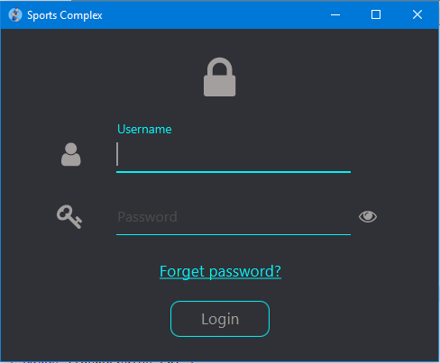

### Forget Password

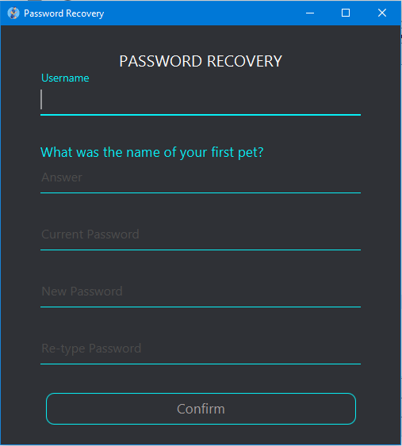

Here the security question “What was the name of your first pet?” is asked and only by answering correctly, user will be able to reset password.

### 3.1.2.2 Registrant Interface

### Main Screen/ Members’ tab

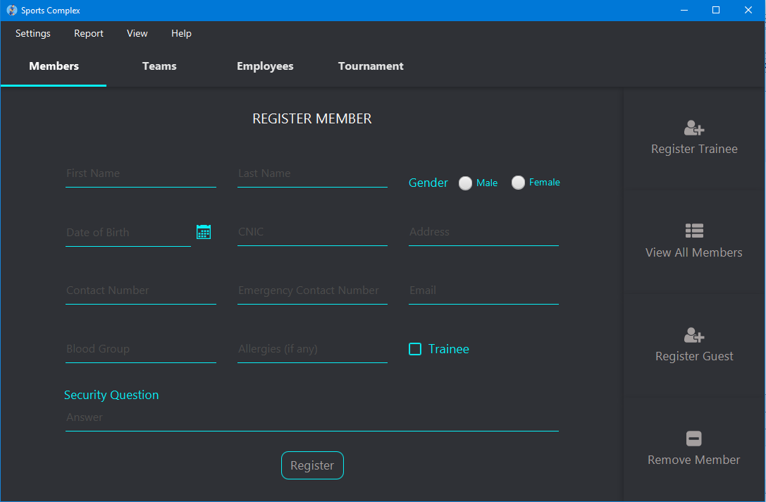

The window is 1080x700 and the size of the window can be increased to full screen, the components will adjust according to the size.

### Register trainee

Clicking the Register Trainee button, opens following window from where a trainee can be registered.

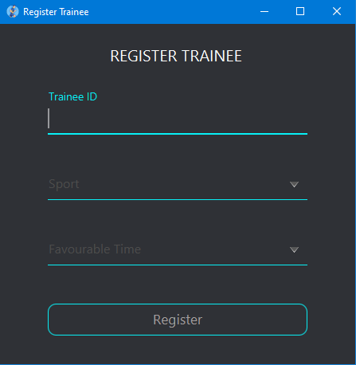

### View all Members

Clicking View All Members button shows the following screen. The table will get filled once the data is added in database.

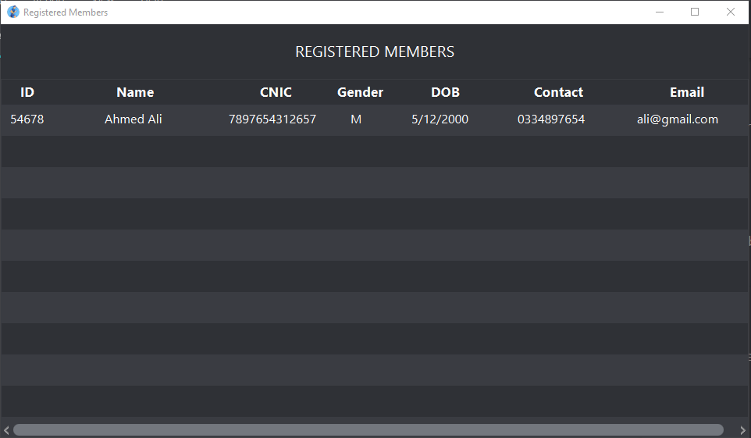

### Register Guest

Clicking the Register Guest button opens following window from where a guest can be registered.

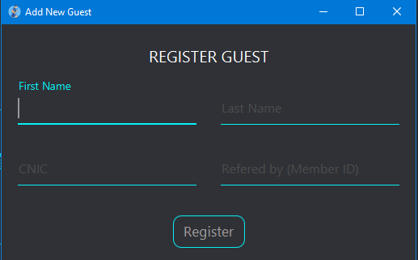

### Remove member

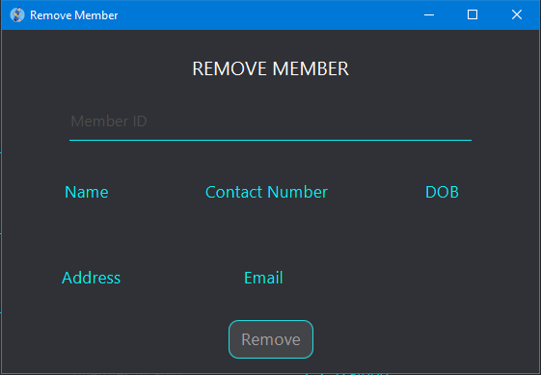

The labels: Name, contact, DOB, address, Email will be updated corresponding to the member ID user enters.

### Teams’ tab

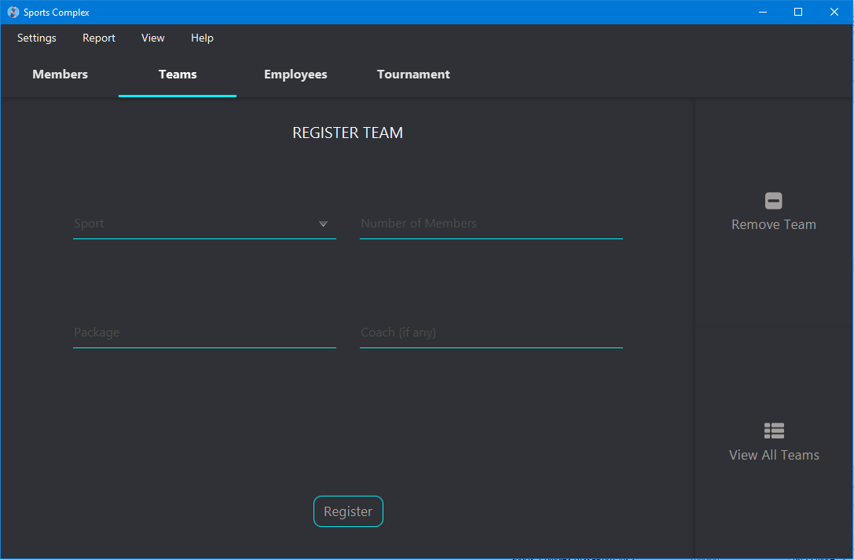

Registrant registers team through this form. Clicking Remove Team and View all Teams load the window similar to the Remove member and View all Members window displayed above respectively.

### Employees’ tab

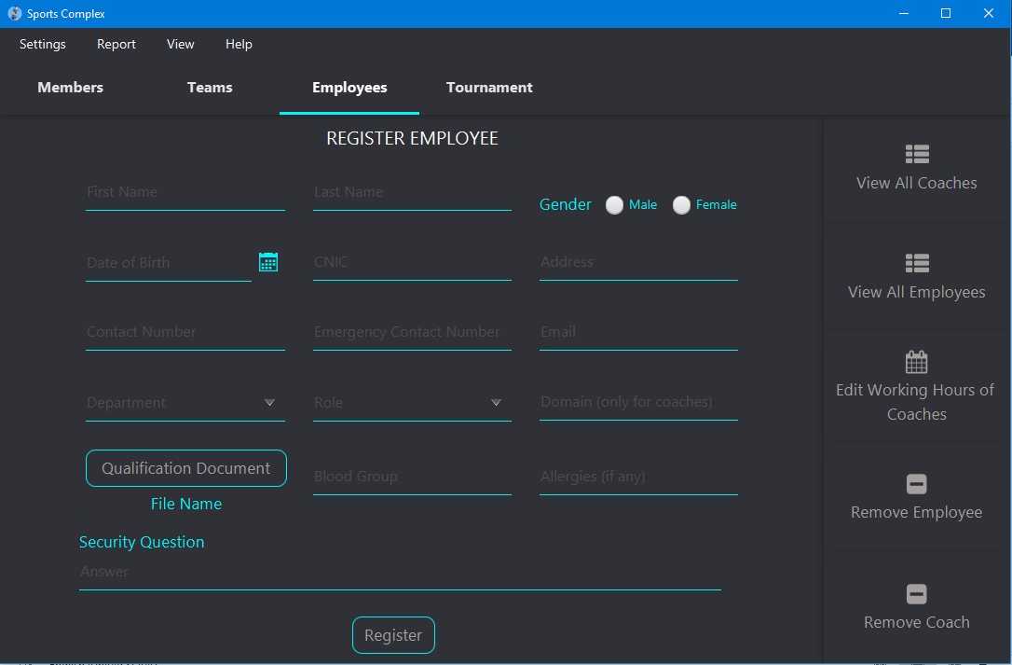

Registrant registers employee through this form. Clicking Remove Employee/ Remove coach and View all Employee/ View All Coaches loads the window similar to the Remove member and View all Members window displayed previously respectively.

### Edit Working Hours

If a coach is registered, clicking the register button automatically loads the window where the working hours of coach is set. This window is similar to the Edit Working Hours of Coaches interface:

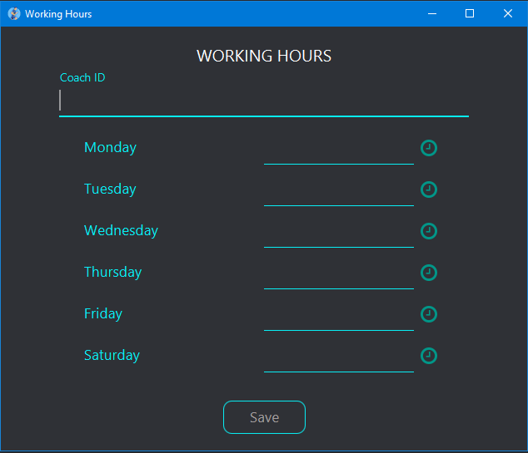

### Tournaments’ tab

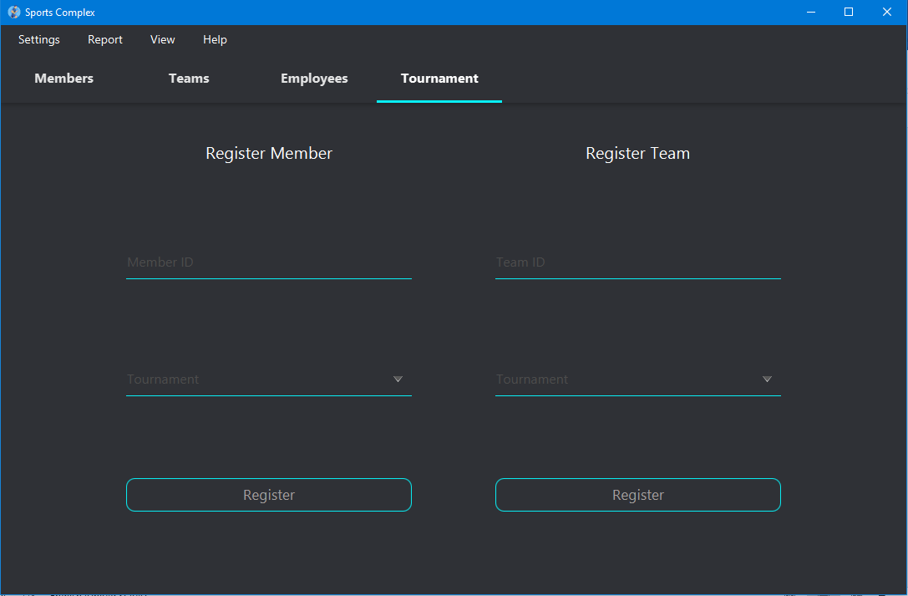

Registrant registers teams or members for tournaments through this form. Clicking View all Tournaments loads the window similar to the View all Members window displayed above.

### 3.1.2.3 Menu bar

Functionality of menu bar is common for all interfaces

### Settings Menu

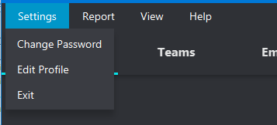

### Change password

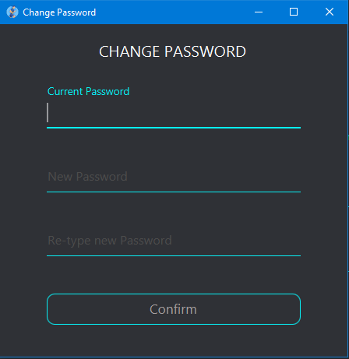

### Edit profile

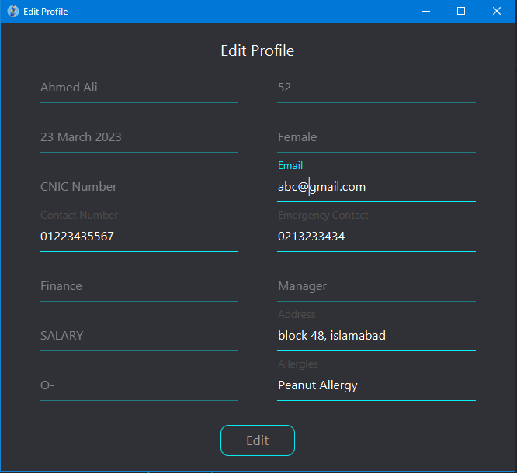

The fields in gray are disabled so the user cannot edit them whereas fields in white are editable.

### Report Menu

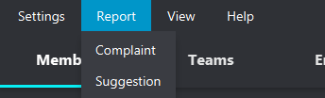

### Register Complaint

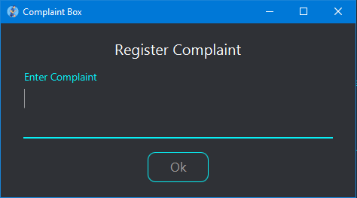

### Register Suggestion

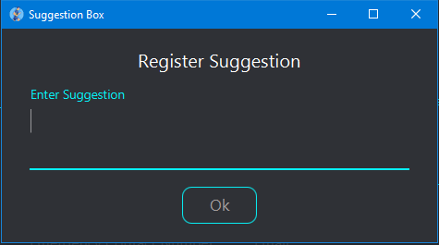

### View Menu

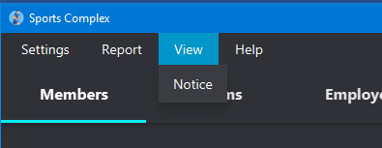

### Notice

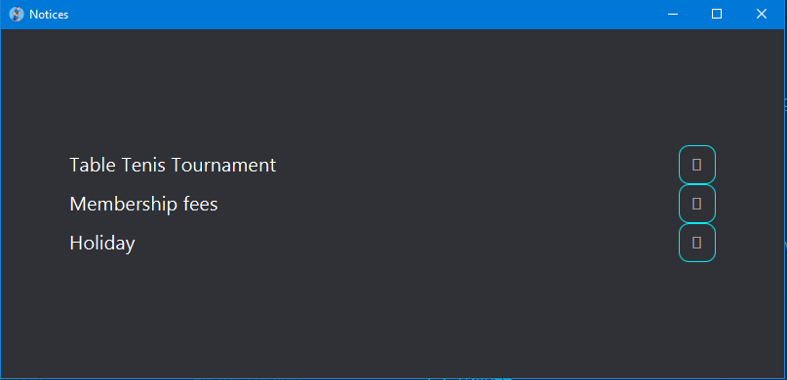

### Expanding first panel:

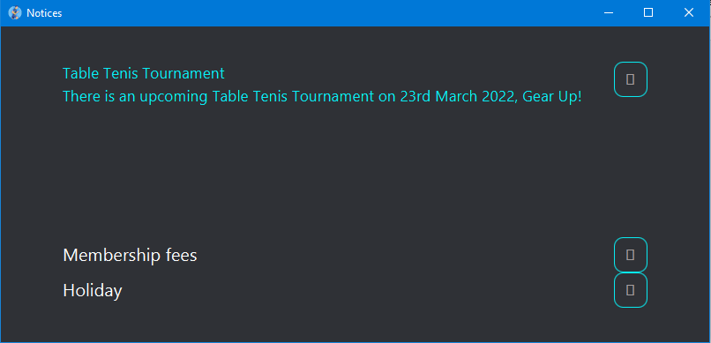

### Help menu

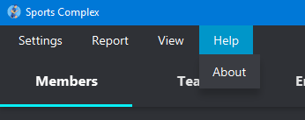

About section displays the details of developers.

### 3.1.2.4 Emergency

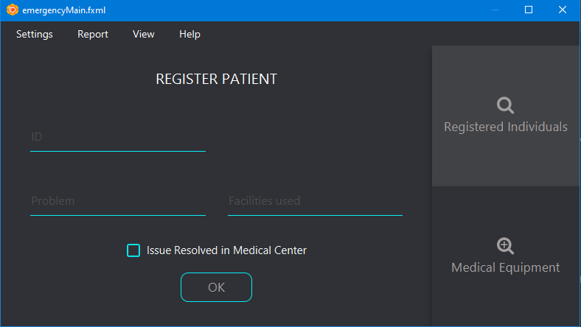

### Registered Individuals

Here, the registered individuals can be searched by ID and a specific blood group.

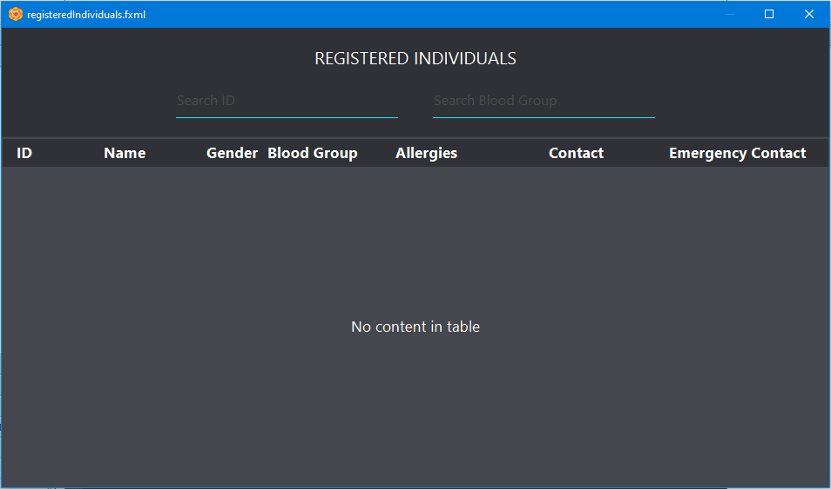

### Medical Equipment

The table shows all the medical equipment, total number, in use and number of available equipment in each case.

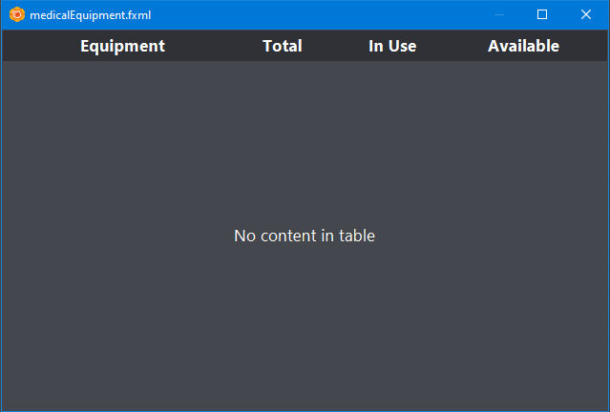

### 3.1.2.5 Coach

### Schedule

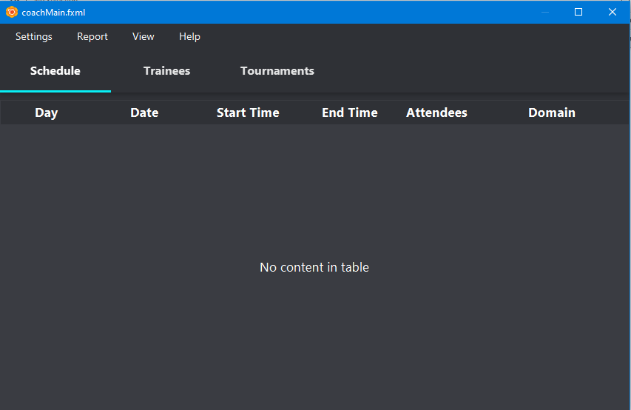

The Schedule for the coach will be displayed here.

### Trainees’ tab

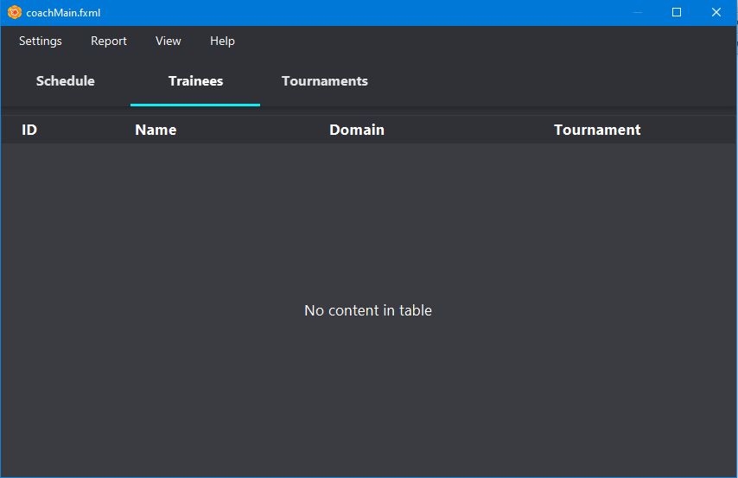

Coach can view the above data of his/her trainee.

### 3.1.2.6 Finance

### Dashboard

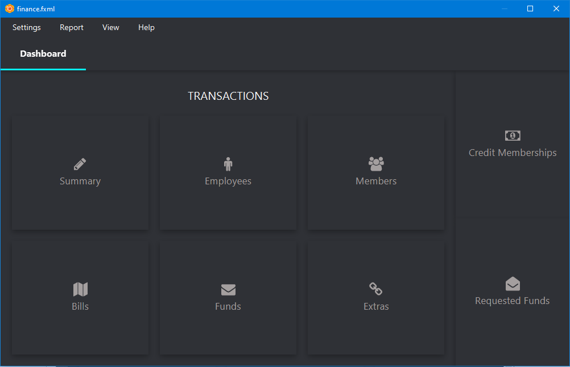

Overall transactions summary can be viewed through Summary button whereas details of each transaction can be viewed by other respective buttons. For example, expenditure on bills can be viewed through Bills button.

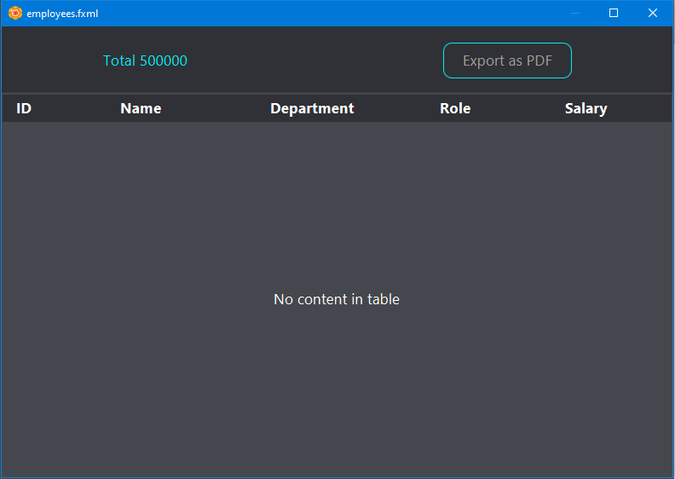

Each transaction detail can be exported as pdf.

### Credit Membership

To credit members, Click on Credit Membership.

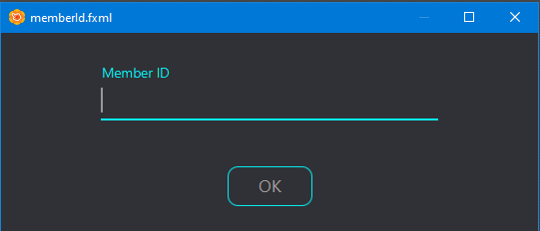

Enter the Member ID and then click on Ok to display transaction form.

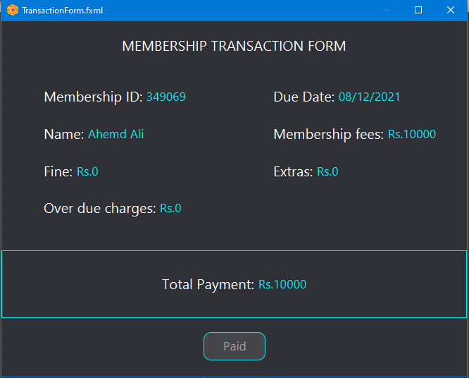

If a department requests for funds, the icon of Requested Funds button becomes red. It remains red till an action is not taken for the request i.e approve or reject funds.

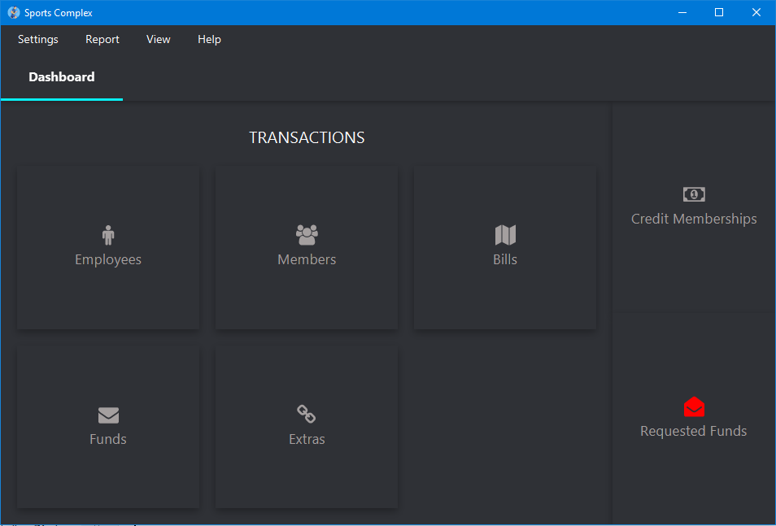

### Requested funds

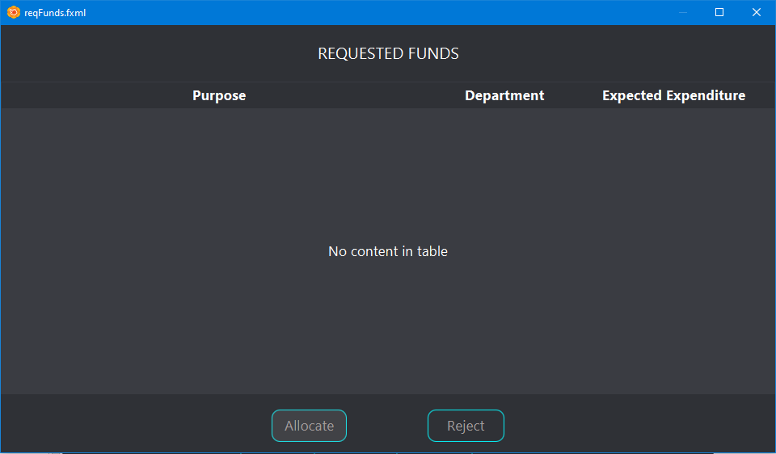

The operator can either allocate or reject the request for funds by selecting it.

### 3.1.2.7 Maintenance

### Main Screen

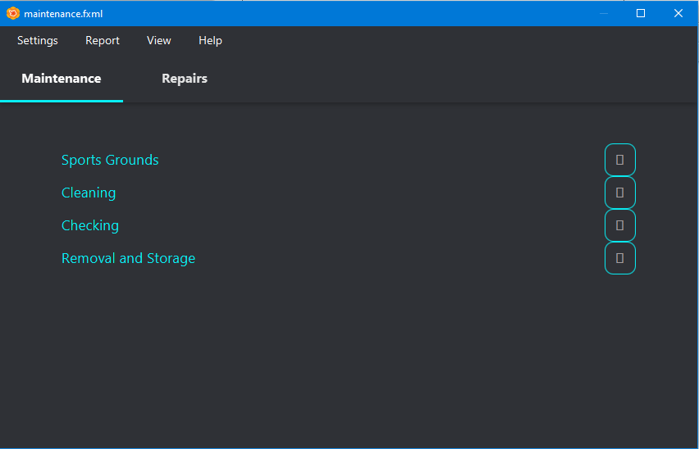

Expansion of each panel gives following view from where the user can select level of completeness of each activity.

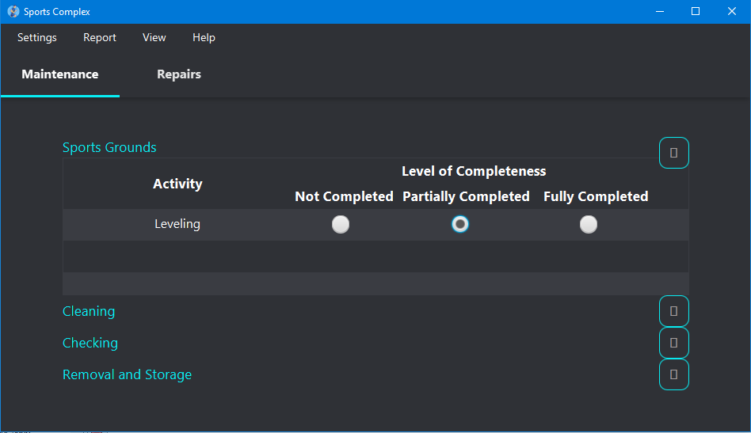

### 3.1.2.8 Repairs

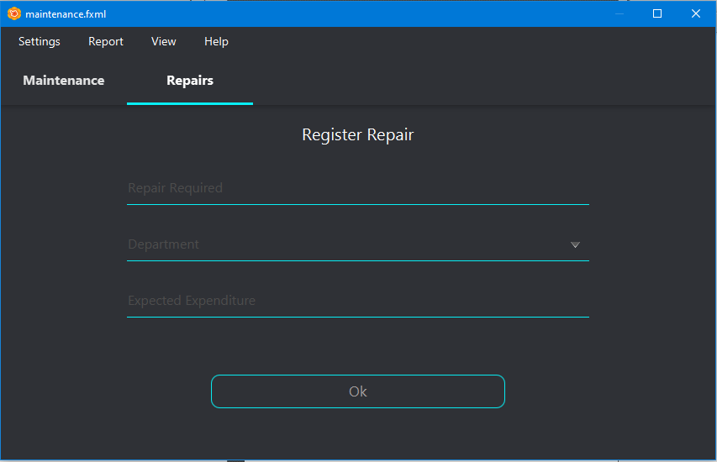

Repairs can be registered and request for funds can be generated to the finance department.

### 3.1.2.9 Attendance system

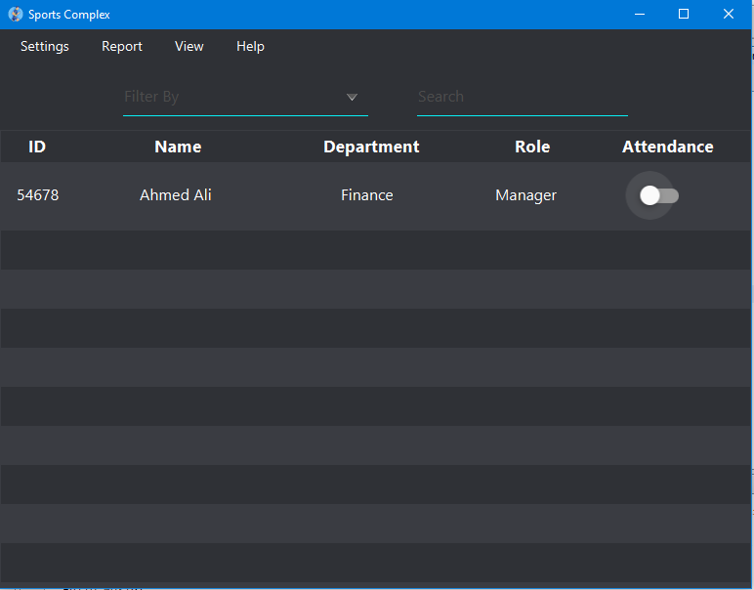

Click on the toggle button to mark present.

### 3.1.2.10 Inventory

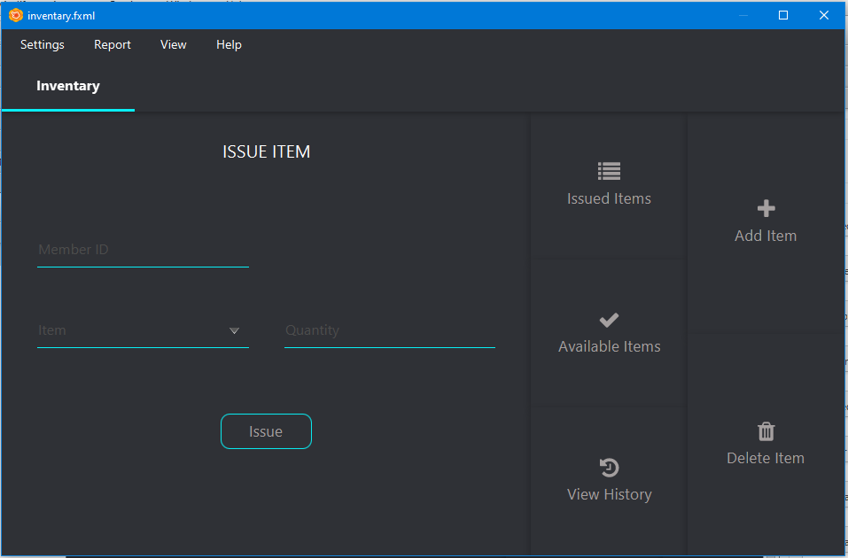

### 3.1.2.11 Warnings/ Error Messages

Appropriate message will be displayed.

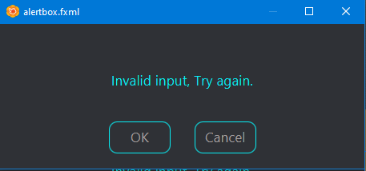

## Hardware Interfaces

This application works on desktop. No other hardware is required.

## Software Interfaces

Application allows transaction details to be exported as pdf file to the desktop. (feature only accessible to finance department).

Application allows populating a file (.docx, .pdf, .pptx) as a qualification document for the employee registration.

# System Features

## Login/Logout

### Description and Priority

Login feature provides secure access to an application by an individual who has valid user credentials. Logging in will allow users to enter a specific interface corresponding to their department and their role in it. This is a high priority requirement as it will allow for many users operating on different interfaces simultaneously.

### Stimulus/Response Sequences

The application shall start with a login page with following fields, icon, button and hyperlink:

* Username (Text field)
* Password (Text field)
* See Password (Eye icon)
* Login (Button)
* Forgot Password? (Hyperlink to password recovery screen)

The user will enter their credentials and press the login button. The successful login will lead the user to their appropriate interface. If the password does not match the password associated with their username, or any of the fields is left blank, or if the username and password do not match any of the existing records, an error message must be reported.

After every unsuccessful login, the username shall be shown as it was before clicking the ‘login’ button. But the password field must be emptied.

The ‘Eye icon’ will allow the users to see what have they entered in the password field; this will otherwise be masked by a string of black dots.

The ‘Forgot Password?’ feature will shift the user to password recovery page. Here the user will be provided the following fields to fill in:

* Username
* Security question
* New Password
* New Password (Retype): To ensure that the user has not ended up mistyping his intended password

If

* the entered username does not match any of the stored records OR
* the entered answer does not match the one stored corresponding to the entered username OR
* the ‘New Password’ and ‘New Password (Retype)’ fields do not match,

an error message must be displayed to the user.

The new password must adhere to the rules of Strong Password.

### Functional Requirements

Every employee must have valid login credentials

Strong Password Requirements:

* Be at least 8 characters in length
* Contain both upper and lowercase alphabetic characters (e.g. A-Z, a-z)
* Have at least one numerical character (e.g. 0-9)
* Have at least one special character (e.g. ~!@#$%^&*()_-+=)

The answer to the security question must be stored at the time of registration.

## Register User

### Description and Priority

This feature is only accessible the Registration department. The registrants will inscribe records of all the employees, members, teams, trainers/coaches and participants of the tournaments. This high priority task must be accomplished in order to shift the system from paper-based to software implementation.

### Stimulus/Response Sequences

The stage will contain appropriate tabs for the registration of the following with respective attributes to be filled:

* **Employees**: name, gender, address, mobile number, email address, date of birth, department, role in that department, emergency contact number, blood group, allergies (if any), employee ID, username, password, security question (for password recovery) and its answer. For trainers/coaches, working hours and domain must also be specified.
* **Members**: membership card ID, name, gender, address, mobile number, email address, date of birth, emergency contact number, blood group, allergies (if any)
* **Teams**: team ID, name, coach (if any), number of members, facility they will avail
* **Trainees**: ID and Trainer ID, favorable time for training
* **Participants of the Tournament**: participant ID (member or team), domain sports and coaches (if any)
* **Guests**: CNIC, membership card ID and name of the guest

### Functional Requirements

Username must obey the following rules:

* Must be 6–30 characters long
* Can be any combination of letters, numbers, or symbols.
* Can contain letters (a-z and A-Z), numbers (0-9), and periods (.).
* Cannot contain an ampersand (&), equals sign (=), underscore (_), apostrophe ('), dash (-), plus sign (+), comma (,), brackets (<,>), or more than one period (.) in a row.
* Can begin or end with non-alphanumeric characters except periods (.)

Password must obey the Strong Password Guidelines mentioned on page 2.

For the registration of employees, qualification docs must be uploaded.

Membership and Employee Id must be five digits long.

A team must have the number of players required by a particular sport as follows:

|  |  |
| --- | --- |
| **Sports** | **Members in the team** |
| Badminton | 2 or 4 |
| Volley Ball | 6 |
| Basket Ball | 5 |
| Football | 11 |
| Cricket | 11 |
| Bowling | 4-8 |
| Squash | 2 or 4 |
| Tennis | 2 or 4 |
| Hockey | 11 |
| Snooker | 2 |

Trainees will be assigned to the trainers based on the area of interest of the trainees and the domain of the trainer. The selection of trainer will also be impacted by the favourable time chosen by the trainee. A trainee cannot get registered for more than 2 facility trainings. Trainees can only be members of the sports complex.

A trainer cannot have more than 5 individuals or 2 teams registered with them.

Only membership holders of the sports complex can bring their guests.

Only the registered teams and members can register for the tournament. The teams must embody the number of players mentioned in table.

The finance department must be alerted for the each registration.

## Delete User

### Description and Priority

* On receiving physical resignation or termination letter of an employee, the registration department shall be able to delete that user.
* If a team or member wants to discontinue their membership, OR
* If the dues of any registered team or member are not cleared for consecutive two months, their membership must be cancelled.

### Stimulus / Sequence Response

The screen will contain tabs for each kind of registration_ employee, member, team, and tournament. For each tab, excluding tournaments, a functionality to delete that registration shall be provided. On clicking on the delete tab, a pop-up window will appear requiring to fill the ID of the registration to be deleted. On filling the ID, the corresponding details of that registration shall be shown on the same window. If the registrant presses the delete button, another pop-up must appear asking for the confirmation of the task.

### Functional Requirements

If the entered ID does not match any of the registrations, an error message shall be produced.

The ID entered must be 5 digits long. Otherwise, error message shall be displayed.

## Edit Details

### Description and Priority

This feature will enable users to edit their details.

### Stimulus / Response Sequence

The edit button lies in the menu bar. On clicking it, the user can edit their details. A confirmation message for the changes will be displayed to ensure that changes have been successful.

### Functional Requirements

A person can edit only some details. Others are restricted:

* An employee cannot change any details of any other employee.
* Employee can only edit address, email, contact number and allergies.
* Trainers cannot change the trainees assigned to them.

## Edit Working Hours

### Description and Priority

The registration department must be able to edit the working hours of the trainers on their request.

### Stimulus / Response Sequence

In ‘Employee’ tab of the registration interface, a tab to edit the working hours of the trainers will be provided. On click, a pop-up window will appear where the registrant will be able to set the timings of the trainer for each day.

### Functional Requirements

The timings entered for the trainer must lie within the operating hours of the Sports Complex.

## Complaints and Suggestions

### Description and Priority

Every user of the Sports Complex Management System shall be able to register complaints or give suggestions. These complaints and suggestions must be presented to the Manager for an appropriate action to be taken. This is a low-priority task because not being able to implement this feature will not cause any hindrance to other functional requirements of the system.

### Stimulus / Response Sequence

Every logged in interface will have a ‘report’ tab on the top having both the complaint and suggestion functionalities in the drop down. Clicking any of the two will lead to a pop-up window. The user will be able to enter the complaint or suggestion in the text field. ‘Okay’ button will register the report.

### Functional Requirements

The name of the originator must be kept confidential and shall not be displayed to the Manager.

## Generate Payroll

### Description and Priority

The payroll generation is authorized to the finance department only. This is one of the high-priority tasks requiring the salaries to be calculated according to the set criteria. Based on this functionality, pay slips will be generated.

### Stimulus / Response Sequence

The automatically generated payroll shall be visible to the members of the finance department.

### Functional Requirements

On 28th of every month, a payroll must be generated based on the current basic pay, allowances and savings of each employee. Gross, net salary of every employee and total sum of salaries to be paid by the sports complex must be visible. Salaries will be calculated based on the role of employee in their respective department.

## Bill Payment

### Description and Priority

Monthly expenses of the sports complex must be deducted from the account of Sports Complex. These expenses include electricity, gas, WIFI, telephone, maintenance bills, property tax, insurance, and funds for updating inventory.

### Stimulus / Response Sequence

A table of the expenses and their details will be visible to the finance department.

### Functional Requirements

On 7th of every month, the monthly expenses will automatically get deducted from the account of Sports Complex if the available amount is not less than the expenses. In that case, an alert will be send to the Manager.

## Credit Memberships

### Description and Priority

The membership dues of the registered teams and the members shall be recorded. Additional amount shall be charged on late payments and relevant actions shall be taken.

### Stimulus / Response Sequence

On receiving payment from every member and team, a transaction shall be recorded. The transaction form will display the fee, additional charges if any, and total amount to be paid.

### Functional Requirements

The due date for the submission of membership fee is the 8th of every month. Late payments within the next three days account for the additional 2% charge on the base fee. From the fourth day onwards, 7% will be charged on the amount to be paid on weekly basis.

The membership will be cancelled if payment is not made for two consecutive months.

## Allocate Funds

### Description and Priority

The funds for the tournaments and repairs shall be approved by the finance department. These funds will be deducted from the account of Sports Complex.

### Stimulus / Response Sequence

Requested funds for the tournaments and the repairs will be visible to the supervisor of the finance department. A button ‘Allocate’ and ‘Refuse’ will be provided against each requirement. On ‘Allocate’, respective amounts will be deducted from the Account.

### Functional Requirements

The funds can be allocated only if sufficient amount is available in the account.

## View Transactions

### Description and Priority

The finance department shall be able to access all the transactions carried out in that month.

### Stimulus / Response Sequence

On the logged in page, every employee in the finance department shall be able to see the dashboard where a button for each kind of transaction shall be provided_ employees, members, bills, funds, extras. Clicking any of them will show a detailed summary of the transactions made for that particular area. The user can also access overall summary of the transactions with respect to each area.

### Functional Requirements

Financial stats shall only be visible to the finance department.

## Print Transactions

### Description and Priority

The finance department shall be able to print all the transactions carried out in that month for each department in detail and also as summary of overall areas.

### Stimulus / Response Sequence

For each transaction table, an ‘Export’ button will be provided that will allow the user to save the data in pdf file format. From there, the document can be printed.

### Functional Requirements

The prints must not be auto-generated.

## Issue Notices

### Description and Priority

The Manager can issue notices for the staff through the system.

### Stimulus / Response Sequence

A text field will appear as a pop-up where the Manager can write notices, change of policies, rules and regulations. After clicking on ‘Enter’, the notice will be become visible to every user of the system.

### Functional Requirements

The system shall not allow the Manager to enter empty notices. The notice must not be longer than 600 characters.

## View Notice

### Description and Priority

Every user of the system shall be able to see what notices have been issued by the Manager.

### Stimulus / Response Sequence

In the menu bar, a notice field will appear. Clicking on it, a user can view all the notices that have been issued by the Manager.

### Functional Requirements

Each notice must appear for a month only.

## View Supervisor Attendance

### Description and Priority

The Manager can view the attendance of the supervisors of each department and facility.

### Stimulus / Response Sequence

An automatically generated table of the attendance of the supervisors will appear on the screen. The table will contain the employee ID, name, department and attendance.

### Functional Requirements

After 10 a.m., the attendance sheet of the supervisors will be visible to the Manager.

## View Complaints and Suggestions

### Description and Priority

The complaints and suggestions submitted by any of the user must be visible to the Manager to take appropriate actions.

### Stimulus / Response Sequence

The Manager can view either Complaints or Suggestions by clicking on the relevant tab. A table will be displayed with the details of the relevant subject. Two buttons_ one to ‘Remove’ and other ‘Addressed’_ must be provided with each tuple.

### Functional Requirements

The name of the originator must be kept confidential and shall not be displayed to the Manager.

## View Repairs

### Description and Priority

The Manager can access the information of the repairs occurring in the Complex.

### Stimulus / Response Sequence

A table will be displayed showing the details of the repairs and funds allocated for it.

### Functional Requirements

Only the repairs occurring in the past one month shall be displayed.

## View Emergency

### Description and Priority

The Manager only shall be able to see what emergencies have occurred in the Complex.

### Stimulus / Response Sequence

A table will be displayed showing the details of the patient, details of the injury/problem encountered, treatment that was given, the date and time of the emergency and the name of the attendant.

### Functional Requirements

Only the emergencies occurring in the past one month shall be displayed. The medical details of the patient must not be visible to anyone except the Emergency Department.

## Change Password

### Description and Priority

Every user can edit their password from their logged in account.

### Stimulus / Response Sequence

From the ‘Settings’ tab, the user can change their password. The user will be required to enter their current password and new password. An extra text field shall be given for retyping of the new password to get a check for mistype.

### Functional Requirements

None of the fields can be left empty. Both new password and new password (retype) must match.

## Maintenance Checkup

### Description and Priority

Safety is one of the main concerns for facilities of Sports Complex. It protects players from unnecessary harm and accidental injury. This feature is for maintenance department and includes:

* Equipment removal and storage in proper area

This avoids accidents in the facility and extends the equipment’s lifespan.

* Maintaining Surface of Sports Grounds
  + Padding
  + Surfacing of Ground
* Cleaning
  + Equipment & Machinery
  + Drag & Mats
  + Towels
  + Algae Treatment & Water Cleaning of Swimming Pool.
* Frequent Checking of Equipment & Tools
  + Equipment/parts of swimming pool (such as pumps, filter and heater)
  + Machinery and equipment related to gyms and sports.
  + Balanced amount of chemical in swimming pool
  + Lubricating machinery

### Stimulus / Response Sequence

Maintenance form will have main 4 type of maintenance described above. When the main heading is clicked it will display sub headings. This will be done through expansion panel. Each subheading will have a radio button that will indicate the level of completeness of that subtype such as completely done, partially done or not done.

### Functional Requirements

No set of radio button can be left empty so that there is a track of completeness of all activities of maintenance.

## Edit Repair

### Description and Priority

This feature will be accessible in the Maintenance Department and help to have the details of the repair required.

### Stimulus / Response Sequence

A form will be filled that will have fields such as the repair required, department to which the repair is related and expected expenditure required. This form will be then send to finance department.

### Functional Requirements

No field in the form can be left empty.

## View Trainee

### Description and Priority

Coach will be able to see the trainee’s details.

### Stimulus / Response Sequence

This feature will display the details of the trainee which he would be training in form of a table such as trainee’s id, name, contact number and domain.

### Functional Requirements

Coaches will not be able to edit the personal information of trainee.

Coaches shall have access to the details of all the trainees under his/her training.

## View Schedule

### Description and Priority

The coaches will have the view of their schedule.

### Stimulus / Response Sequence

Schedule will be displayed in form of a table having fields such as date, start & end timing, attendees and domain.

### Functional Requirements

Coaches should have a daily schedule with days, start & end timing, attendees and domain.

## Mark Attendance

### Description and Priority

This feature will be accessible to attendant of registration department that helps to mark the attendance of the employees and staff of each department of sport complex.

### Stimulus / Response Sequence

The attendance record will be in form of table having fields of ID, name, department, role, attendance.

There will be toggle button indicating present or absent.

### Functional Requirements

Person can be present or absent not both at the same time. It cannot be NULL as well.

One person will handle the attendance of employees of all departments.

## View Medical Details

### Description and Priority

This feature will be accessible to Emergency Department and helps to retrieve the details of the employees in case of medical emergency. The number and availability of different medical facilities in the inventory is also visible to the Emergency.

### Stimulus / Response Sequence

A form will be filled that will have fields such as the emergency problem, the facility used, and detail of the patient and a checkbox showing either the problem was solved in sport complex or sent to hospital.

If blood is required, we can search if that blood group is similar to any registered person as there will be a display of different blood group.

### Functional Requirements

Emergency department will have access only to medical details of registered members such as blood group, allergies, name, id, emergency contact details.

The number and availability of different medical equipment, first aid, blood group, ambulances will be visible to the Emergency.

## View Inventory

### Description and Priority

This feature will be accessible to inventory department and will keep track of the all the machinery, tools, equipment of different department own by sport complex.

### Stimulus / Response Sequence

To issue item from the inventory, the user ID and the quantity of the items borrowed must be provided. There will be a button for every issued item named ‘Return’ that will indicate that the item has been returned back. Add item button will allow adding new items to the inventory. ‘Delete’ button will allow deletion. ‘Available items’ button will display all the items available in the inventory. View history button will indicate the time when the item was issued and when it was returned.

### Functional Requirements

Inventory department should have track of all the inventory of the sport complex.

It should be able to delete items from inventory if it is not working or damaged and add new items to the inventory.

It will keep track of all the things taken from inventory and that received back at the end of the day.

The user ID of the employees and members and the number of borrowed items shall be entered at the time of issue.

# Other Nonfunctional Requirements

## Performance Requirements

* Maximum Screen refresh time is expected to be 0.5sec
* Minimum 7 Processed Transactions/second shall be made possible
* Maximum response time must not exceed 0. 55sec

## Safety Requirements

Before installation and deployment of the application, it should be thoroughly tested for error, viruses and potential harms.

## Security Requirements

There should be a backup of the database somewhere safe and sound. So that incase of system failure or accidental damage, the data remains unaffected.

## Software Quality Attributes

* It must have sufficient reliability
  + mean time to repair must not exceed 0.44sec
  + probability of unavailability must not exceed 0.25
* Efficiency of the application and server is ensured during the working hours of employees and minimum errors should occur.
  + The availability of the system must have a probability of 0.88
* Robustness is made less (by minimizing time to restart after failure)
  + percentage of events causing failure must be kept below 4%
  + probability of data corruption on failure must not exceed 0.2
* Usability shall be ensured
  + Training time for learning the features of system = 3 hours total
  + Chances of error after training must be less than 5%
* Correctness must be ensured by validating and testing all the system.
* Priority
  + Correctness = Testability > Usability > Reliability = Availability > Reusability > Flexibility > Maintainability

## Business Rules

* An employee after successful login shall be able to access data related to their department only. And the functionalities accessible must also be in line with the role of that employee in their department.
* The change in data that is interlinked if changed then change should be reflected everywhere.

# Other Requirements

The project database shall be based on relational data model with all the security, integrity and domain constraints ensured. The legal requirements include consideration of copyright laws and license agreements for using any third party software in this system.

Appendix A: Glossary

|  |  |
| --- | --- |
| **Word** | **Explanation** |
| Payroll | All the salary details of employees |
| Radio button | An icon for options out of which only 1 can be selected |
| Expansion Panel | A container that can be alone or combine with larger one such as card.  In simple words a heading with further hidden subheadings |
| Toggle button | Icon for choosing between two mutually exclusive events. |